How To: Set Alteryx to "Python Allow Hide Encryption" Mode

The PythonAllowHideEncryption key is a registry key that allows Alteryx supported Python SDK tools to be run on the Gallery. When this key is not set, Python tools cannot be run on the Gallery and users will get one of the following errors.
- Failed to decrypt value for adl_SecretKey!
- Failed to decrypt values for clientSecret!
- Failed to decrypt value for password!
- Traceback (most recent call last): RuntimeError: Internal Error: DecryptPassword - buffer too small
- Traceback (most recent call last): RuntimeError: DecryptPassword only works with User and Machine encrypted passwords
The following Python based tools are supported and published by Alteryx Products on the Alteryx Analytics Gallery.
- Azure Data Lake Tools
- Dynamic CRM Tools
- Google BigQuery Tools
- OneDrive Tools
- Power BI Output
- Salesforce Input Tool
- Box Tools (Beta)

Prerequisites

- Alteryx Server 2019.3 or greater
- Alteryx Designer 2019.3 or greater (Admin or non-Admin)

Procedure

The PythonAllowHideEncryption key must be set on each user’s machine, as well as on all Worker nodes. Worker nodes must also have the tools installed.
Alteryx version 2019.3 or greater must be installed on the user's machine, as well as the Server and all Worker nodes. The process is the same for a non-Admin install on the user's machine as it is for an Admin install.

Administrators will need to create a new string value PythonAllowHideEncryption under the Alteryx Registry Key.
Note: This key must be set on each user’s machine as well as on all Worker nodes.

Create Key
- Type regedit in Windows Start Menu
- Browse to the folder location: HKEY_LOCAL_MACHINE\SOFTWARE\WOW6432Node\SRC\Alteryx
- Right click and select New > String Value
- Set the KeyName to PythonAllowHideEncryption and the Value to true
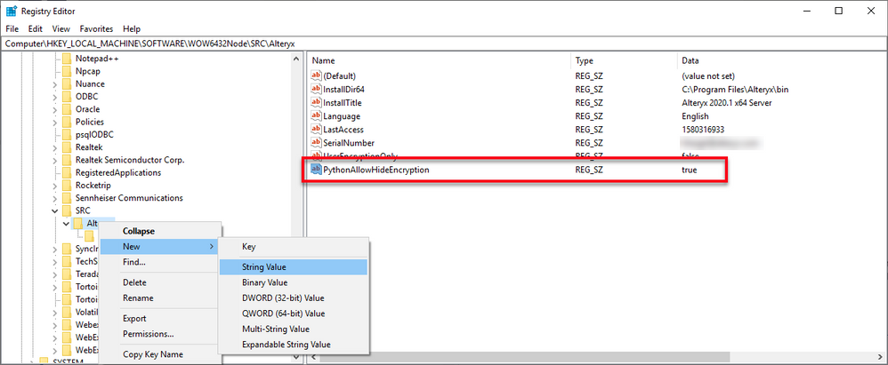

Gallery Interaction Changes

The below descriptions assume that all users interacting with the Gallery have the registry key set to true.
- Uploading to Gallery:
  - Encrypted values for the supported Python tools will be updated to a hide encryption once you publish to the Gallery.
- Running on Gallery:
  - Only workflows that originated from machines with the registry key set will be able to run successfully on the Gallery. The worker nodes must also have the registry key set and the respective Python tools installed.
- Opening from Gallery:
  - The original encryption method will be restored. These Python based tools might need to be reconfigured for the workflow to run.

